About SPD:

1.What Services Does SPD Provide?
SPD delivers over 20 programmes spanning the full life cycle, grouped into the following service areas:

Early Intervention
• Early Intervention Programme for Infants and Children (EIPIC) — therapy and educational support for children from birth to 6 years with developmental, physical, sensory or intellectual disabilities.
• EIPIC Under 2s — specialist programme for infants under 2 years.
• EIPIC@Centre — small-group therapy and educational intervention with regular progress assessments.
• DS-Plus — in-preschool support for children aged 2–6 requiring low levels of early intervention, facilitating transition to mainstream classrooms.
• Development Support (DS) & Learning Support (LS) — targeted support for children in mainstream pre-schools with mild learning or developmental difficulties.

Therapy Services (SPD Therapy Hub)
• Occupational therapy, speech therapy, and physiotherapy for children and adults.
• Community rehabilitation and outpatient therapy for adults with physical and neurological conditions.
• Continuing Therapy Programme for children under 16 years.

Day Care & Senior Care
• Day Activity Centre (DAC) — day activities and skills training for adults with disabilities.
• Senior Care Centres — SPD@Melody Spring Yishun, SPD@Canberra, SPD@Toa Payoh (dementia-friendly) — daycare and rehabilitation for seniors and adults with disabilities or disabling conditions.

Employment & Vocational Support
• Sheltered Workshop — supported employment for persons with disabilities in bookbinding, book restoration, artisan work and other trades.
• Supported Employment Programme — job placement and on-the-job coaching in open employment settings.
• Vocational training in IT, hospitality, retail, administrative and job-specific skills certified under WSQ (Workforce Skills Qualifications).
• SPD Ability Enterprise — social enterprise arm providing meaningful employment and generating revenue for SPD's programmes.
• SPD Artisan Collab — employment via artisanal product creation and sales.

Assistive Technology
• Specialised Assistive Technology Centre (Specialised ATC) at Enabling Village, Lengkok Bahru.
• Assessments (clinic-based, school, workplace, home) to identify suitable AT devices.
• Prescription and application support for Assistive Technology Fund.
• Augmentative and Alternative Communication (AAC) assessments and training.
• Technical support (virtual and in-person) and sales coordination for AT devices.
• Periodic AT training courses for clients and caregivers.

Education Support
• SPD Education Programme — bursary awards and educational support for students with disabilities.
• School-based outreach and teacher training on managing pre-schoolers with learning difficulties.

Enabling Services Hubs (ESH)
• ESH@Tampines (launched August 2023) — community hub at Tampines West Community Club for persons with disabilities and caregivers in the East.
• ESH@Punggol (launched July 2024) — serving Hougang, Punggol, Sengkang and Serangoon communities, in partnership with SG Enable.
• Life skills training, caregiver support, community outreach and referral services at heartland level.

Case Management & Social Support
• Specialised Case Management Programme — coordinated support for complex cases involving multiple needs.
• Caregiver Support — counselling, training, support groups and respite care for caregivers of persons with disabilities.

Community Inclusion & Lifelong Learning
• Community activities, recreation and social integration programmes.
• Disability Etiquette Talks and public awareness initiatives.
• Photography for Good exhibitions showcasing beneficiary stories.
• Canteen enclaves in secondary schools — employment and inclusion training pathways.

2. What Events Does SPD Organise?
SPD runs a diverse calendar of events ranging from large public fundraising and community inclusion events to professional development and corporate engagement activities.

SPD Ability Walk (Annual Flagship Event)
• SPD's largest annual public event, bringing together individuals of all abilities to champion disability inclusion.
• Format: Charity walk (typically 3–5 km) along Singapore River, combined with carnival activities, disability simulation stations and a scavenger hunt (2025 edition).
• Scale: Thousands of participants including corporate teams, families, students and beneficiaries.
• Fundraising component: Participants raise pledges; Top Individual and Top Corporate Fundraiser prizes awarded.
• Virtual Challenge add-on: Virtual walking/running campaign run throughout August preceding the main event.
• Recent editions: SPD Ability Walk 2024 (60th anniversary, Singapore River), SPD Ability Walk 2025 (10th edition, SG60 theme — Walk, Hunt & Celebrate).

SPD Charity Golf
• Annual charity golf tournament held at prestigious venues (e.g. Singapore Island Country Club).
• Primarily targets corporate donors and golf enthusiasts.
• The 2024 edition raised funds in celebration of SPD's 60th anniversary. The 2022 edition raised $308,000.
• Includes corporate donation packages with branding recognition and tax-deductible benefits.

SPD Charity Hongbao
• Annual Chinese New Year fundraising initiative encouraging individuals, schools and corporations to donate via red packets (hongbao).
• Mechanics: SPD provides hongbao packets and collection boxes to participating companies and schools; collections are retrieved after CNY holidays.
• School partnerships reinforce values of giving and disability awareness among students.
• Corporate participants engage employees and business partners in the giving initiative.

Anniversary & Gala Dinners
• Major milestone dinners for key anniversaries (50th in 2014 at Fullerton Hotel; 60th in October 2024 at Pan Pacific Singapore).
• Attended by approximately 300–400 guests including donors, volunteers, government representatives, community partners, and VIP guests (e.g. Prime Minister).
• Includes SPD Patron Awards, Distinguished Patron Awards and Youth Aspiration Awards recognising long-term donors and outstanding beneficiaries.

Community Inclusion Events (ESH-led)
• "Eat, Play, Live Together" — community events at community clubs (e.g. Tampines West CC) open to the public, featuring game booths, music performances by artistes with disabilities, assistive technology showcases and disability etiquette talks.
• Organised through SPD's Enabling Services Hubs in partnership with approximately 80 community organisations.

Professional & Sector Events
• Sector symposia for healthcare and social service professionals (e.g. Early Intervention symposium, April 2024; community therapy symposium).
• Allied Health Professional events for those working in or interested in Singapore's community setting.
• Social Service Tribe Connect — networking and career development sessions for social service professionals.
• Disability Etiquette Talks — public awareness sessions at community events.

Corporate & Third-Party Fundraising
• SPD is adopted as charity partner for third-party events (e.g. HSBC Women's World Championship 2024, Kowloon Club charity dinners and concerts).
• Corporate volunteer days with disability simulation activities at SPD centres.

Who Attends SPD Events?
SPD events attract a broad cross-section of participants reflecting the organisation's wide network of stakeholders:
• Persons with Disabilities (Beneficiaries): SPD clients across its programmes — children through seniors with physical, sensory, developmental and learning disabilities.
• Caregivers & Family Members: Parents, spouses and family members of persons with disabilities who support and accompany beneficiaries.
• Corporate Donors & Sponsors: Businesses that adopt events, purchase corporate packages or sponsor activities; many send employee teams.
• Volunteers: Individual and corporate volunteers supporting event operations, activities and outreach.
• Government Representatives: Ministers and officials from relevant ministries (Social and Family Development, Culture, Community and Youth, Law); VIPs serve as Guests-of-Honour.
• Social Service Sector Partners: Staff and representatives from other Voluntary Welfare Organisations (VWOs), NCSS, SG Enable, and sector agencies.
• Healthcare & Allied Health Professionals: Occupational therapists, speech therapists, physiotherapists and other professionals, especially at professional development events.
• Schools & Students: Students participating in Charity Hongbao, disability awareness programmes and canteen enclave partnerships.
• General Public: Families, individuals and community members, especially at inclusive community events and the Ability Walk.
• Donors (Individual & Institutional): Long-term supporters recognised via Patron and Distinguished Patron Award programmes.

How Are Registrations Currently Handled?
SPD uses a combination of online and offline registration channels, varying by event type:

Online Registration (Primary Channel)
• Participants register through SPD's own website event pages (spd.org.sg/events/).
• Registration confirmed via email sent to the registrant upon receipt of payment.
• Online response forms are used for initiatives like the Charity Hongbao.
• Early bird pricing and group discounts (e.g. groups of 4+, children aged 4–12) are offered via the online portal.
• Corporate group registrations are handled via email (events@spd.org.sg) or WhatsApp (65790669).

Offline Registration
• PDF response forms available for download; completed forms emailed back to SPD.
• Phone registration supported via SPD's events hotline (6579 0780).
• Walk-in or coordinator-managed registration for corporate participants — companies appoint internal coordinators who manage their employee registrations and T-shirt/goodie bag collection.

Registration Confirmation & Cutoffs
• Confirmation sent by email after payment is received; participants advised to contact SPD if no email is received.
• Registration closes on a set date (e.g. 25 August for Ability Walk 2024) or when capacity is reached, whichever is earlier.
• Registration fees are non-refundable.

Payment
• Event fees are collected online through SPD's website payment gateway.
• Donations associated with events can be made online, via PayNow, or via mobile banking.

How Is Attendance Currently Tracked?
Based on publicly available information, SPD's current attendance tracking approach includes:

Pre-Event Confirmation Lists
• Registrant lists are compiled from online and offline registration forms.
• For corporate participants, employee lists are coordinated through company-appointed coordinators.
• Participant confirmation slips or emails serve as the primary identification document at collection and entry points.

T-shirt & Goodie Bag Collection as Attendance Proxy
• For events like the Ability Walk, pre-event T-shirt and goodie bag collection at designated pop-up locations (e.g. Tiong Bahru Plaza) effectively serves as a pre-event attendance check-in.
• Participants present a soft or hard copy of their confirmation slip/email for verification at collection points.
• T-shirt and goodie bag collection is time-limited and location-specific, creating a structured collection record.

On-Site Attendance at Main Events
• Finisher entitlements (gifts, medals) are collected on-site within a set window (e.g. 9am–11am at the event ground), providing an implicit on-site attendance count.
• Disability simulation activity participation is logged as part of corporate engagement tracking.
• No publicly disclosed QR-code check-in or real-time digital attendance system has been identified for SPD events.

Programme-Level Attendance
• For professional and sector events (symposia, Disability Etiquette Talks), session attendance is tracked by SPD staff and reported in annual reports.
• SPD's Annual Report (e.g. FY2024/2025) publishes aggregate attendance and impact figures for its programmes and events.
Note: SPD's internal operational systems for attendance tracking are not publicly disclosed. The tracking methods described above are inferred from publicly available event information. It is likely that manual reconciliation against registration lists is a significant part of the current process.

How Is Feedback Currently Collected?
SPD's feedback collection practices, based on publicly available sources:
• No specific public-facing post-event feedback survey mechanism has been identified in SPD's event communications.
• Participant satisfaction is likely assessed informally through coordinator debriefs and volunteer feedback.
• Third-party event partners (e.g. HSBC for the Women's World Championship) provide their own event feedback to SPD.

Programme Feedback (Services)
• SPD's therapy and intervention programmes incorporate regular client progress reviews and goal assessments.
• Caregiver and client feedback is collected through case management touchpoints and support group interactions.
• SPD@Tampines and other satellite centres note regular programme reviews as part of service quality management.

Sector & Stakeholder Feedback
• Professional events (symposia, Social Service Tribe Connect) include structured feedback through discussions and networking debriefs.
• SPD reports outcomes to government bodies (NCSS, MSF) and publishes annual impact metrics, suggesting internal data collection and reporting systems.

Reputational & Award-Based Validation
• SPD uses external benchmarks as proxies for feedback: 7 consecutive Charity Transparency Awards (2016–2024), CARF accreditation, Enabling Mark Gold (SG Enable), and Singapore Health Quality Service Awards.
• These accreditations require structured client feedback and outcome data as part of the assessment process, indicating that formal feedback mechanisms exist internally even if not publicly visible.

Current Challenges
Current Challenges
Manual Processes:
- Manual verification of registrations
- Manual WhatsApp confirmations
- Manual compilation of attendance records → through Excel spreadsheet (i think)
- Manual event feedback collection → inconsistent
- Significant administrative effort required for reporting

Most time consuming task for staffs:
- Significant administrative effort for reporting

Information SPD needs for reporting:
- Attendance
- Participant feedback

Why current methods are inefficient:
- Lack of effective attendance tracking system
- Unable to efficiently measure impact of funded programmes
- Ineffective participant feedback collation
- Unable to effectively generate reporting data
Therefore, it is difficult for SPD to evaluate whether programmes/events organised are meaningful to caregivers and disability communities.

Feature planning

Scope (Version 1 Prototype)

Admin
✓ Login
✓ Create, Edit and Delete Events
✓ View Attendance Dashboard
✓ View Feedback Dashboard

Caregiver
✓ Register for Event
✓ Submit Feedback Form

Priority | Admin Features | Caregiver Features
Must Have | Login, Event Management, Attendance Dashboard, Feedback Dashboard | Event Registration, Feedback Submission
Should Have | Attendance Check-In, Export Reports, Capacity Monitoring, Search Filters | Notifications, QR Check-In, Mobile-Friendly UI
Future Features | Analytics Dashboard, AI Analysis, Multi-User Roles, Notification Center | Profile Management, Accessibility Features, Notification Center

Admin

ADMIN FEATURES

Must Have Features (Version 1 Prototype)

1. Admin Authentication
Description: Secure access to the system.
Requirements:
- Login using username and password.
- Logout functionality.

2. Event Management (not priority)
Description: Create and manage events.
Requirements:
- Create new events.
- Edit existing events.
- Delete events.
- View upcoming and past events.
- Store event information:
  - Event title
  - Date and time
  - Venue
  - Description
  - Maximum capacity

3. Attendance Dashboard
Description: Monitor participant registrations.
Requirements:
- View all registered attendees.
- Search attendees by name.
- View total number of registrations.
- View attendance list for each event.

4. Feedback Dashboard
Description: Review caregiver feedback.
Requirements:
- View all submitted feedback.
- Filter feedback by event.
- Display average event ratings.
- View comments and suggestions from caregivers.

Should Have Features

1. Attendance Check-In System
Requirements:
- Mark participants attended.
- View attendance status.

2. Export Reports
Requirements:
- Export attendance records to CSV or Excel.
- Export feedback reports.

2.5 Send Reports
- Draft Email Template - Manual 1 time use or AI Assisted

3. Event Capacity Monitoring
Requirements:
- Display remaining slots.
- Prevent overbooking.

4. Search and Filter Functions
Requirements:
- Filter events by date.
- Search participants
- .- Search feedback responses.

5. QR Code Scanner
- For both registration and feedback form

6. AI Help Desk
- If the Admin runs into issues
- Through API request to preferred model

7. 3rd party social media integration
- - Eg, Discord, Whatsapp, Face book, Telegram
- To have quick relay of information and an alternative path to communicate

8. Direct communication with Admins

Future Features

1. Analytics Dashboard
Requirements:
- Attendance trends.
- Satisfaction trends.
- Event popularity analysis.
- Charts and statistics.

2. AI Sentiment Analysis
Requirements:
- Categorize comments as positive, neutral, or negative.
- Summarize common concerns and suggestions.

3. Multi-User Roles
Requirements:
- Super Admin.
- Event Staff.
- Volunteer accounts.

4. Notification Center
Requirements:
- Send announcements.
- Broadcast event updates.

Caregiver

CAREGIVER FEATURES

Must Have Features (Version 1 Prototype)

1. Event Registration
Description: Register for events.
Requirements:
- View available events.
- Register attendance.
- Enter:
  - Caregiver name
  - Contact number or email
  - Name of person with disability (PWD)
  - Relationship to PWD
- Prevent duplicate registrations.
- Display registration confirmation.

2. Feedback Submission
Description: Provide post-event feedback.
Requirements:
- Rate overall satisfaction (1–5 stars).
- Rate usefulness of the event.
- Provide comments and suggestions.
- Submit feedback successfully.

Should Have Features

1. Automated Notifications
Requirements:
- Receive registration confirmation.
- Receive event reminders.
- Receive post-event feedback reminders.

2. QR Code Attendance Check-In
Requirements:
- Receive a unique QR code after registration.
- Use QR code for event check-in.

3. Mobile-Friendly Interface
Requirements:
- Responsive design.
- Easy-to-use forms suitable for caregivers with varying levels of digital literacy.

4. Auto Translation of the app
- Implemented using AI. User can press a button at the bottom of their screen to activate
- User can select language through Drop down box, with their language name in their native language OR AI Voice Recognition
- Note: Since users may not understand the default language, you have to rely on visual cues/design, eg: Icons or language to tell them how to change the language

5. AI Help Desk
- If the Admin runs into issues
- Through API request to preferred model
6. Direct communication with Admins
- Ticketing
- Communicate any issues with attendance - Eg, Late, attended event but not logged in

Future Features

1. Caregiver Profile Management
Requirements:
- Create personal profiles.
- Update contact information.
- Save PWD details.
- View attendance history.
- Persons Unique Disability Tag

2. Notification Center
Requirements:
- Receive announcements.
- Receive schedule changes.
- Receive event reminders.

3. Accessibility Features
Requirements:
- Large text mode.
- High contrast mode.
- Screen reader support.
- Multi-language support.- added under 4, Auto translation of app

User Flow Diagram

User Flow Diagram
Link to Draw.io Doc → SPD User Flow Flow chart.drawio
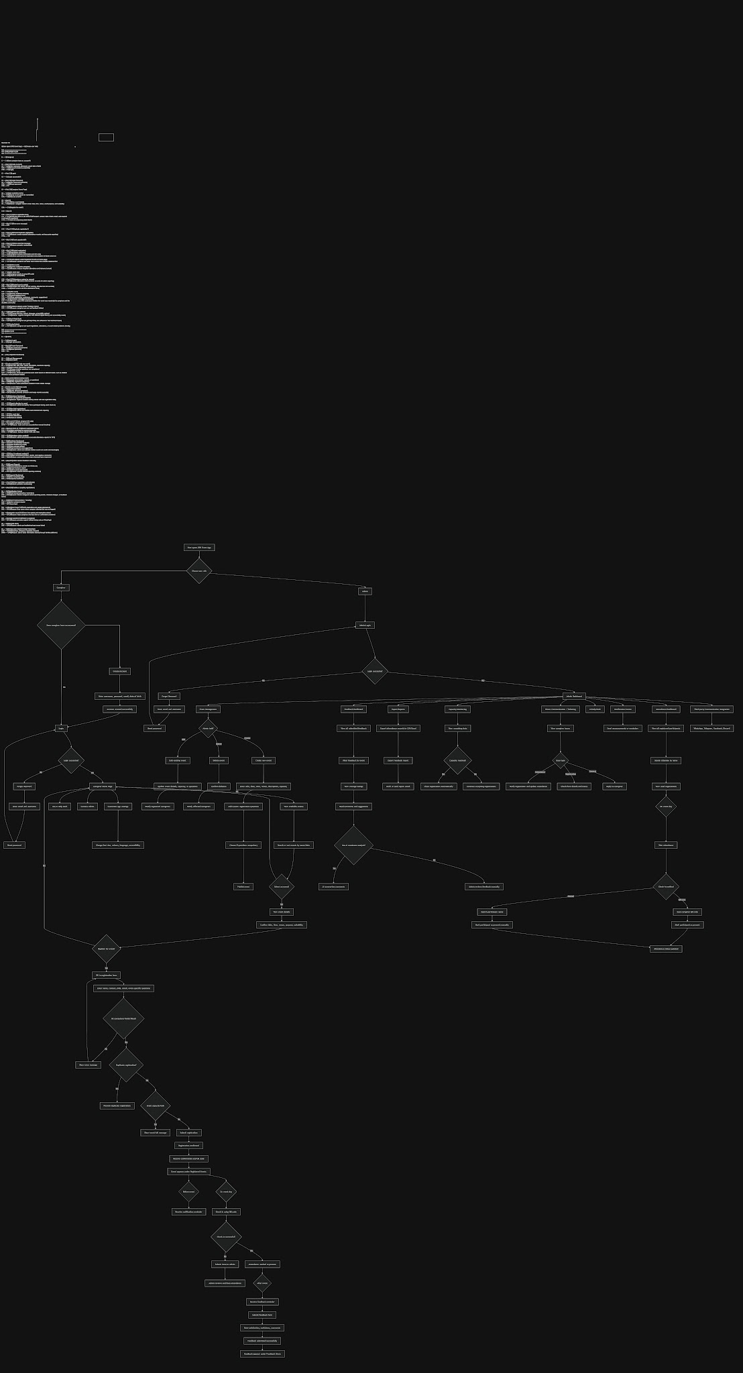

Simplified Version for Presentation:

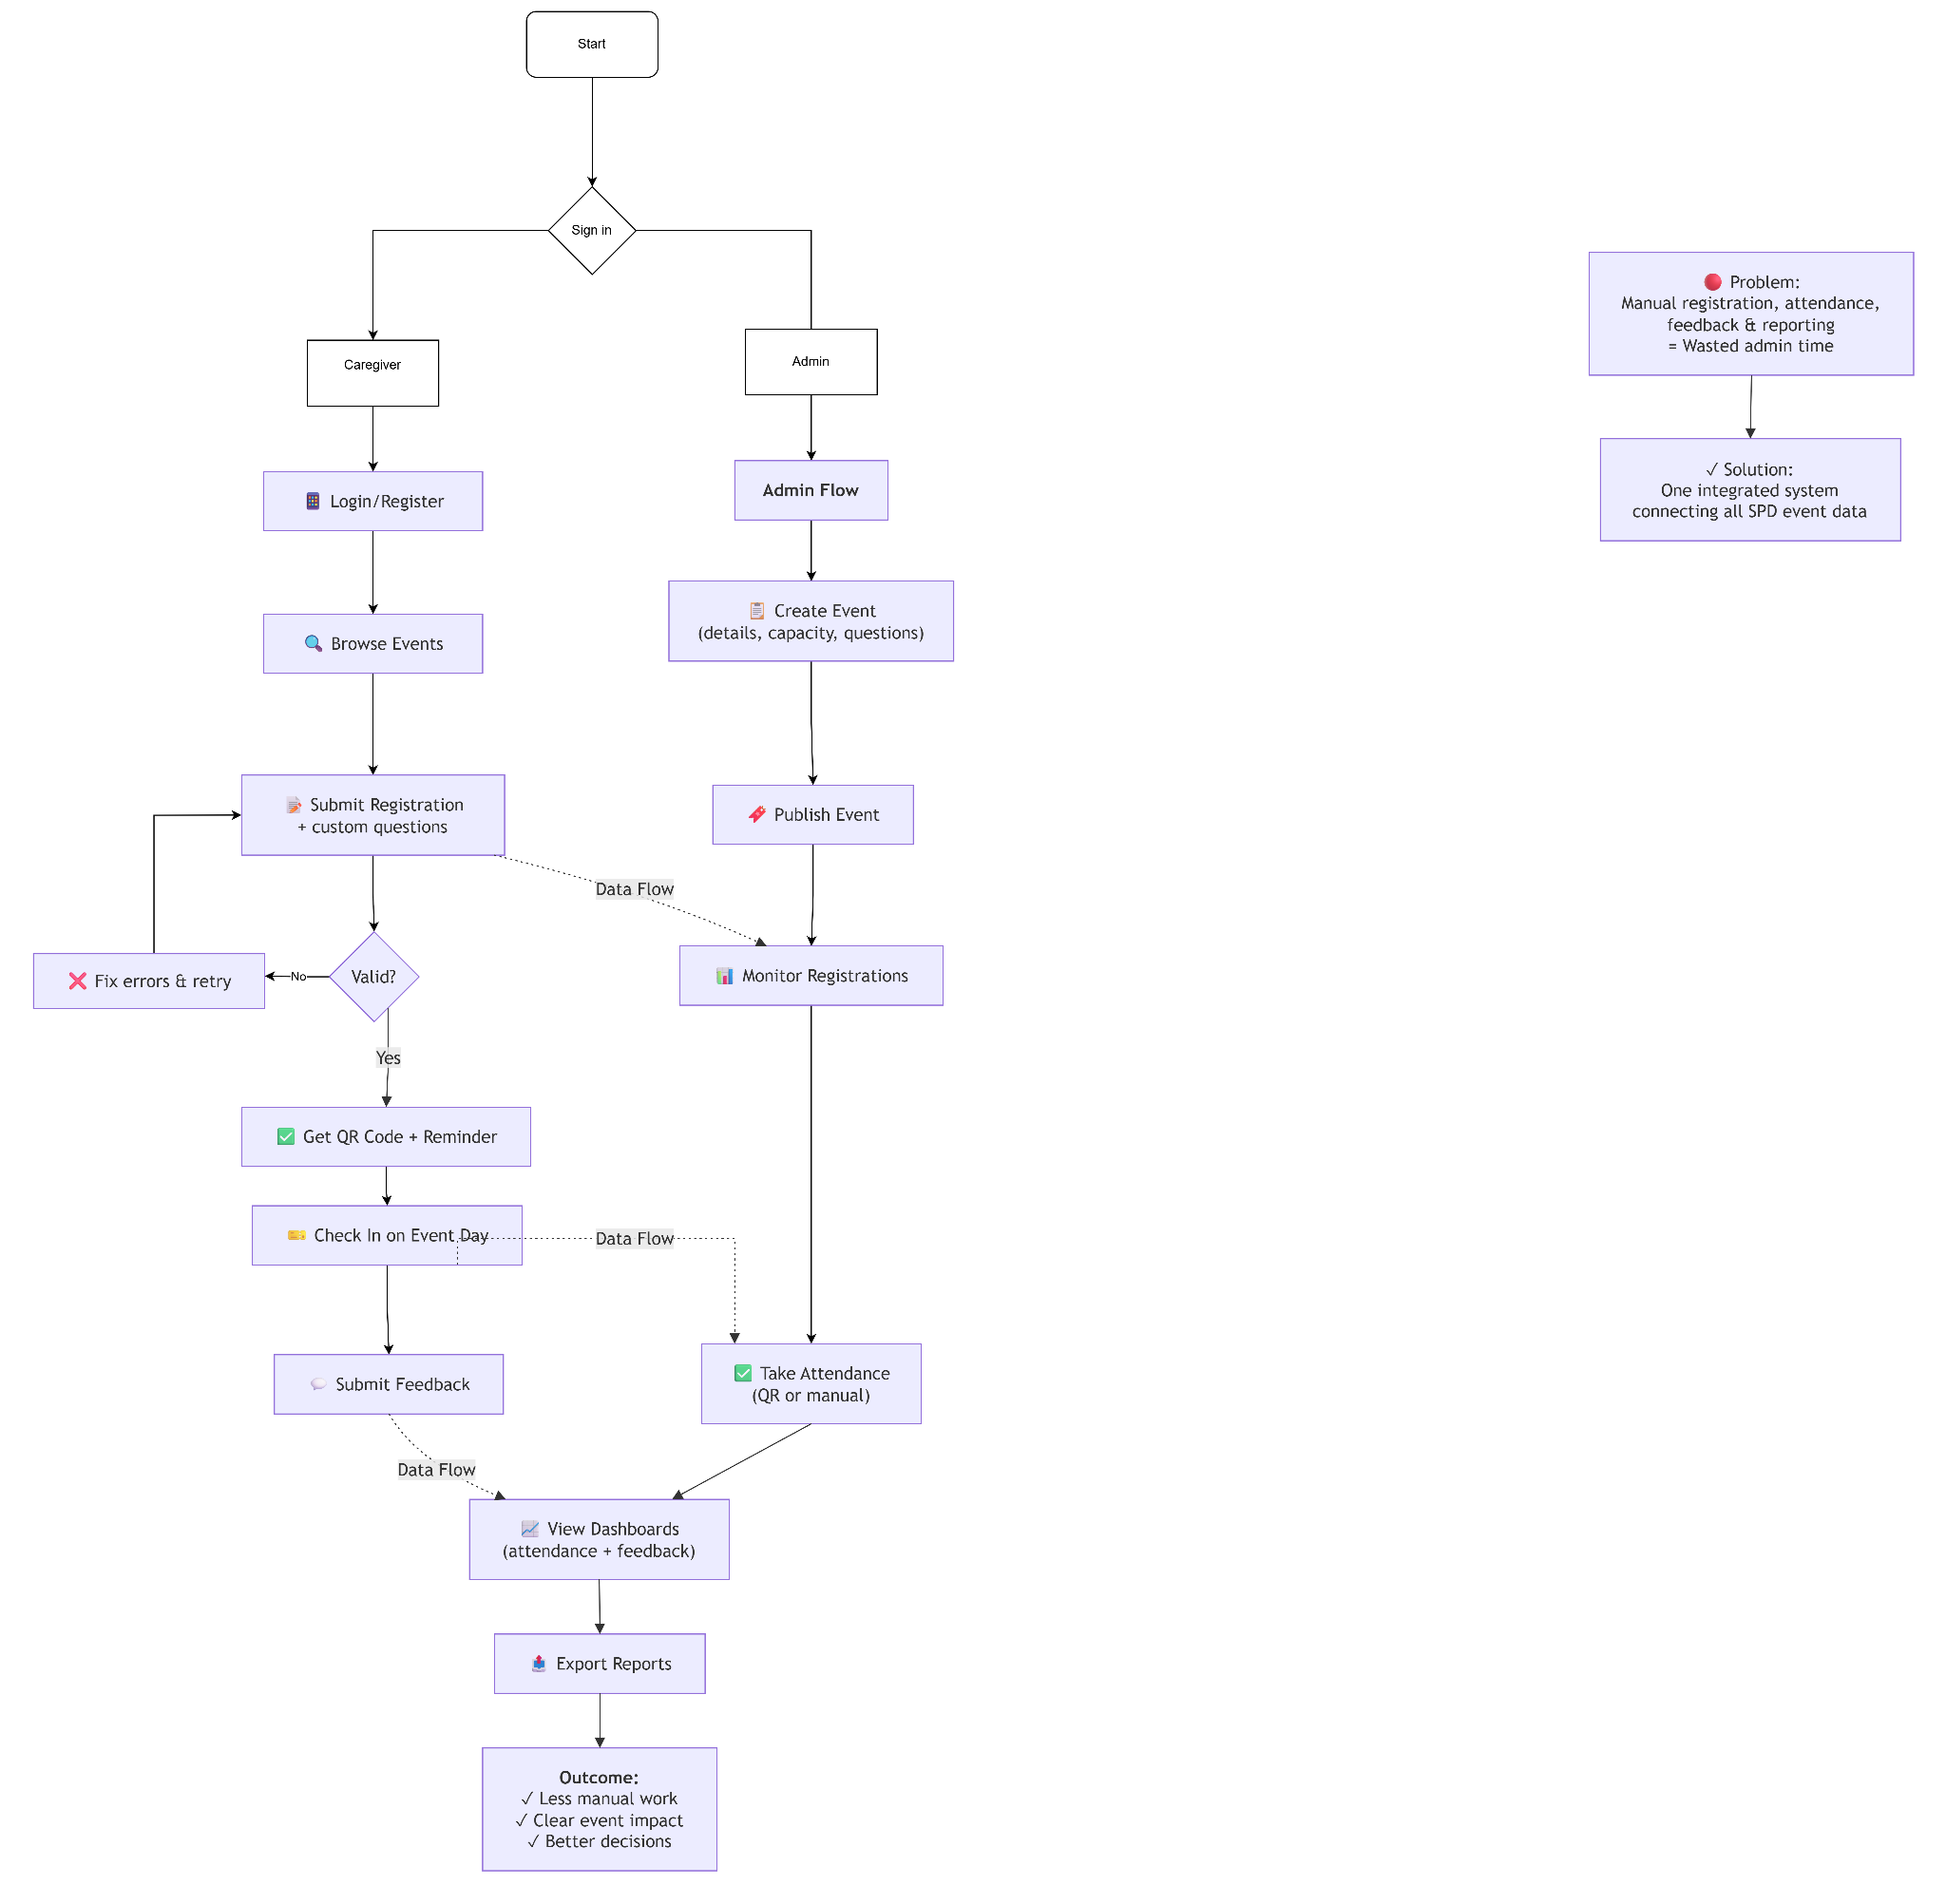

App improvements
What we have: functional app that allows you to go into a caregiver an admin profile
Problems:
you have to manually click and there is no “dummy accounts” that has the only acces to log in for caregiver and admin manually

What gender during event registration form

There is a caregiver + person with disability name but there shld only be the person with disabilities. However the title should just be : “ Full Name (as per NRIC/FIN/Passport No.)”
As there are people without disabilities joining just to raise funds for the organisation.

Make every section compulsory with a red * at the top and prevent them from going to the next page after log in or submitting the application if they do not fill it up. Date of birth should be required as well

Admin shld have the ability to customise any event they have in mind to have specific questions that need or need not be compulsory and subjected to event (eg. some events allow kids while others dont)

Forgot password page shld bring user to a password reset page that asks for email and username

For dont have account. Make a create account function for users to create account with username, password, date of birth, email

For the design page, make it a app customisation page, where users can customize every option provide( eg. font size, colour)

After their registration form is made, their names shld immediately pop up in the attendance section and not any random name generated, additionally the admin should be able to see every single person who registered, the information that they have put in such that they can

For home screen notification icon, it should inform the user of upcoming events made by the admin or events they registered for and all details necessary

For registered events and feedback given that are shown on the front page, it shld be based on real details whether they actually register or gave feedbacks.

For search function for events, it shld be able to search and sort out the events based on their names

All functions shld be customisable by the admin

On the day of the event, the admin should have an option somewhere where they can take attendance on the presence of the people who signed up. Right now they are saying that

Feedback form shld also be seen by admin and shld be real

